Starfish Student Log in:

https://ric.starfishsolutions.com/starfish-ops/support/login.html?tenantId=9348

To create an appointment with your faculty advisor:

- Log into Starfish

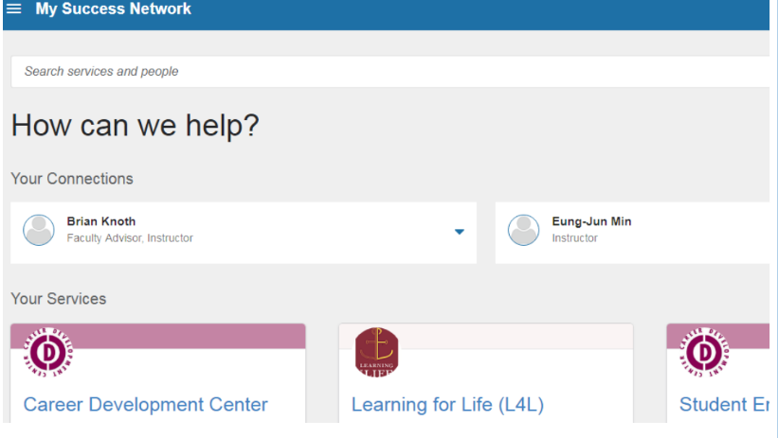
- After you log into Starfish, you can navigate to the My Success Network page (you can also make this the default page in your profile settings).

- Click on your advisor’s name (it will bring up a few different ways to communicate with them)
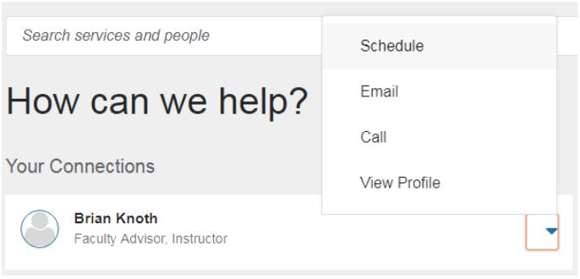

- Click schedule to see the available times

- Let your advisor know what you want to talk about, and find a time that works for you (if you need more time you can change the duration on the confirmation screen)
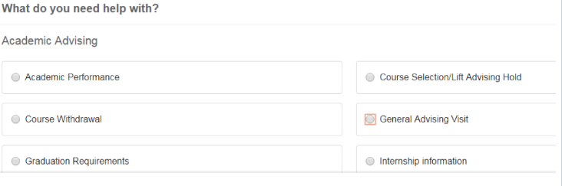
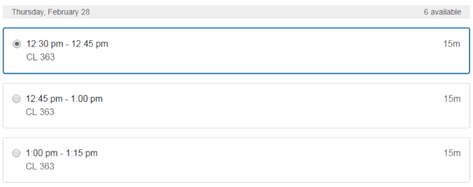

- If you need an appointment longer than 15 minutes, at the confirmation screen, select Change Duration…
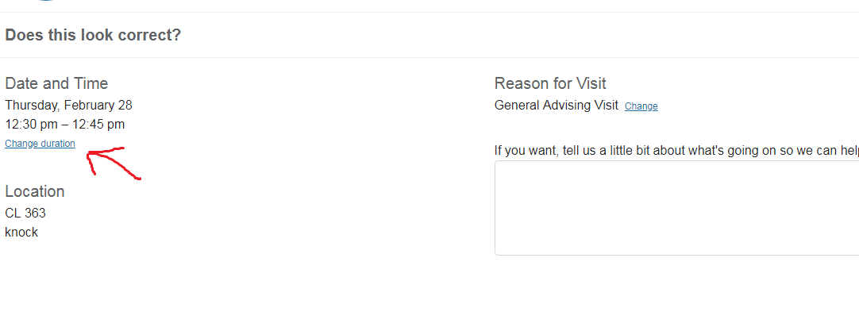
Then…
